Face Recognition Attendance Management

System

S. R. S. Report – I


GLA University

Team Members:

Abhishek Sharma

161500007

Ayush Goel

161500157

Deepak Raj

161500187

Ashish Varshney

161500143

Table of Contents

DOCUMENT APPROVAL

1. INTRODUCTION 4

1.1 CURRENT SYSTEMS 4

1.2 MOTIVATION 4

1.3 SCOPE 4

1.4 DRAWBACKS 5

2. GENERAL DESCRIPTION 5

2.1 PRODUCT PERSPECTIVE 5

2.2 PROPOSED SOLUTION 5

2.3 PROPOSED SYSTEM COMPONENTS 6

2.4 PROPOSED OUTCOMES 6

2.5 CONTRIBUTIONS & BENEFITS 6

3. SPECIFIC REQUIREMENTS 7

3.1 EXTERNAL INTERFACE REQUIREMENTS 7

3.1.1 User Interfaces 7

3.1.2 Hardware Interfaces 7

3.1.3 Software Interfaces 7

3.1.4 Communications Interfaces 7

3.2 FUNCTIONAL REQUIREMENTS 7

3.2.1 System Architecture…………………………………………………………….………8

3.3 USE CASES 9

3.3.1 Use Case diagram 9
3.3.2 Use Case Details…………………………………………………………………...

3.4 Project plan…………………………………………………………………………………10

3.4.1 Objectives……………………………………………………………………………..10

3.4.2 Goals…………………………………………………………………………………..10

4. ANALYSIS MODELS 11

- 1 Data Flow Diagrams (DFD)……………………………………………………………...12

4.2 SYSTEM

ANALYSIS…………………………………………………………………………………………
………….…...13

4.2.1 Registration Flow…………………………………………………………………………………………………….13

4.2.2 Attendance Flow……………………………………………………………………………………………………..14

4.2.3 Generating Attendance Flow……………………………………………………………………………………15

Software Requirements

Specification

Pageii

5. NON-FUNCTIONAL REQUIREMENTS 16

5.1 Performance 16

5.2 Reliability 16

5.3 Availability 16

5.4 Security 16

5.5 Maintainability 16

5.6 Portability 16

6. LOGICAL DATABASE REQUIREMENTS 17

Software Requirements

Specification

Pageiii

1. Introduction

The Attendance Management System has become an important factor in the education field. This system should help the professors and lecturers in marking the attendance by reducing their effort and the time consumption. The study findings enables the definition of the project problem statement, its objectives, scope and advantages of the Face Recognition Attendance Management System.

1.1 Current Systems

At present attendance marking involves manual attendance on paper sheet by professors and teachers but it is very time consuming process and chances of proxy is also one problem that arises in such type of attendance marking. Also there are attendance marking system such as RFID (Radio Frequency Identification), Biometrics etc. but these systems are currently not so much popular in schools and classrooms for students.

So, why not shift to an automated attendance system which works on face recognition technique? Be it a class room or entry gates it will mark the attendance of the students, professors, employees, etc.

1.2 Motivation

The main motivation for us to go for this project was the slow and inefficient traditional manual attendance system. These made us to think why not make it automated fast and much efficient. Also such face detection techniques are in use by department like crime investigation where they use CCTV footages and detect the faces from the crime scene and compare those with criminal database to recognize them.

1.3 Scope

The scope of the system is to have a high-tech environment in the GLA University. That means by using the face recognition attendance management system, the university will transfer to the technical attendance system from a traditional attendance system. This system will add some features in the dynamic classroom management system of our university by marking the attendance of every student using the image processing and computer vision technology in every classroom at GLA University. That will help the university use the technology in effective ways:

- Make the attendee process easier and effective.

- Help faculty in the attendance process every time.

- Mange and organize the attendance data of every student.

Software Requirements Specification Page4

1.4 Drawbacks in existing system

  - These attendance systems are manual

  - There is always a chance of forgery (one person signing the presence of the other one) Since these are manual so there is great risk of error

  - More man-power is required (some person to take attendance)

  - Calculations related to attendance are done manually (total classes attended in month) which is prone to error. It is difficult to maintain database or register in manual systems

  - It is more costly (price of register, pen and the salary of person taking attendance)

2.General Description

Over the past decade, taking down student’s attendance process had been developed and changed. The driven force of this development is the desire to automate, facilitate, speed up and save time and efforts. Although that the attendance systems are around us everywhere, GLA University lecturers still use a traditional way to record students’ attendance through calling out students’ roll numbers. This way is time consuming and associated with high error scales. In this project, we attempt to reduce wasted time, eliminate buddy clocking, and automate the process. Our system uses facial recognition technology to record the attendance through a high resolution digital camera that detects and recognizes faces and compare the recognize faces with students’ faces images stored in faces database.

Once the recognized face matches a stored image, attendance is marked in attendance database for that person. The process will repeat if there are missed faces. For example, if there are 4 faces missed for a bad position while the detecting phase, then this phase will start again to detect the missed faces and recognize them and continue the attending process. By the end of the month, a monthly report is send to the lecturer contains attendance and absence rates as a chart and the names of absentees. Also, a warning message sends to the student if he passes the allowed number of absence.

2.1 Product Perspective

This product Face Recognition Attendance Management System depends on the vast database of GLA University for the records of the students. The product will automate the various task associated with handling student details, surveillance inside the class and optimum performance thus helping the college authorities to ensure the smooth working of these processes,

2.2 Proposed Solution

To overcome the problems in existing attendance system we shall develop a Biometric based attendance system over simple attendance system. There are many solutions to automate the attendance management system like thumb based system, simple computerized attendance system but all these systems have limitations over work and security point of view. Our proposed system shall be a “Face Recognition Attendance System” which uses the basic idea of image processing which is used in many secure applications like banks, airports etc.

Software Requirements Specification Page5

2.3 Proposed System Components

Following are the main components of the proposed system

- Student Registration

- Face Detection

- Face Recognition

Feature Extraction

Feature Classification

- Attendance management system

It will allow uploading, updating and deletion of the contents of the system.

Attendance management will handle:

Automated Attendance marking

Manual Attendance marking

Attendance details of users.

2.4 Proposed System Outcome

- System will only allow authenticated user to login to the system and/or make changes to it.

- It will allow user to mark attendance of the students via face recognition technique.

- It will detect faces via webcam and then recognize the faces.

- After recognition it will mark the attendance of the recognized student and update the attendance record.

- The user will be able to print these record details afterward.

2.5 Contributions & Benefits

Face recognition is the most natural biological features recognition technology according to the cognitive rule of human beings; its algorithm is ten times more complex than a fingerprint algorithm. Face recognition is featured by the following advantages compared to fingerprint:

→ Accurate and Fast Identification → High Usability and Security
→ User friendly design

Software Requirements Specification Page6
→ Easy to operate.

→ Faster method to mark the attendance.

→ Time Saver

→ Also helps in maintaining the vigilance in the class through the CCTVs and Monitoring Cameras to ensure the discipline.

→3. Specific Requirements

3.1 External Interface Requirements

- Reports are generated as per the requirement.

3.1.2 Hardware Interfaces
Hardware Requirement | Core 2 Duo 2nd generation
System Configuration | RAM – 2 GB DDR – 3
Operating System | Windows – 7/8/8.1/10
Other hardware | D3D D8801 Home Security Camera (128 GB, 1 Channel)

3.1.4 Communication Interface

The machine will have to be the part of the Local Area Network to access central database.

3.2 Functional Requirements

The functional requirements that our product Face Recognition Attendance Management System will fulfill are given below.

- Taking and tracking student attendance by facial recognition in specific time.

- Sending the names of the absent student directly to the lecturer

- Permitting the lecturer to modify the student absent or late.

- Showing the names of who is absent or late in the screen to avoid errors.

Software Requirements Specification Page7

3.2.1 System Architecture
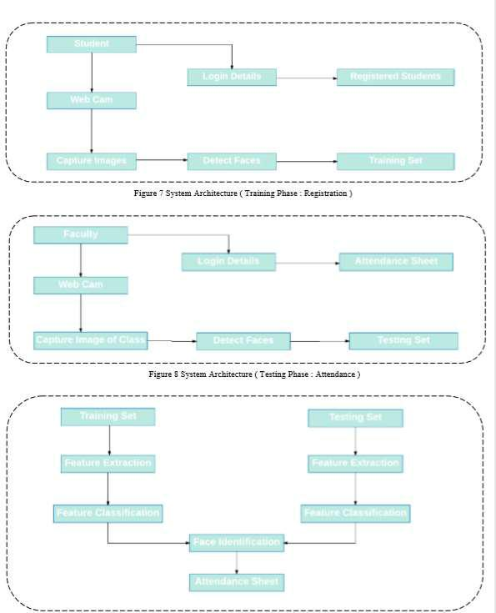

Software Requirements Specification Page8

3.3 Use Case
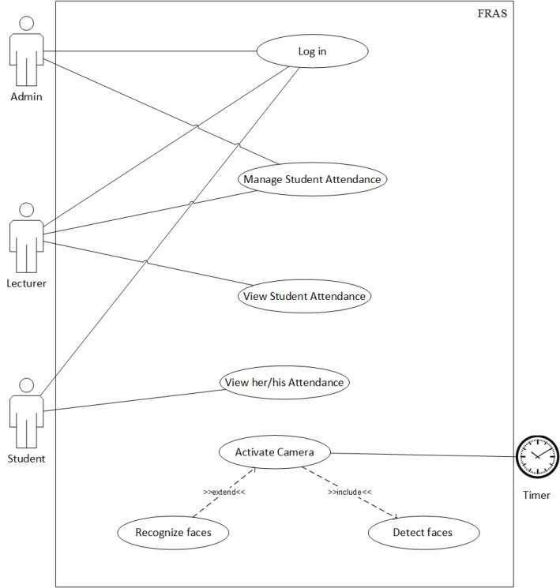

Figure numbering or name
As shown in the use case diagram, the FRAS has actors named Admin, Lecturer and Student which are the main users of the system. Other actor, timer which turns camera on to record attendance by detecting and recognizing faces.

Software Requirements Specification Page9

Use Case Description (Detailed Use Cases)

Log in

Table 3.1: Log-in use case description


Use Case Name: | Log in | Use Case Number:1
Actors: |  | Admin, Lecturer, student
Description: | This use case describes how Admin, Lecturer and student
 |  | log into the system.
Triggering events: | Lecturer, admin and student enter his username and
 |  | password.
Steps Performed (Main | 1-System requires users to enter username/password.
Path): |  | 2-Users enter username/password.

3-System validate entered username/password.

4-The use case ends successfully.

Preconditions: 1. System installed on pc.

2. Admin, Lecturer and student must be authorized.

Post-conditions: Log in is successfully.

Alternate: If the Admin, Lecturer and student is not fill correctly, the log in fails.
(2) Manage student attendance.

 | Table 3.2: Manage student attendance use case description
Use Case Name: |  |  | Manage student attendance | Use Case Number: 2
Actors: |  |  | Admin, Lecturer.


Software Requirements Specification Page10

  - Project Plan
The main aim of the project is to simplify the attendance system. Reduction of the time wastage during the traditional attendance system is the main motto. The basic plan for the completion of the project is the team work and achieving the goals within the time assigned to them. The work will be distributed to different members with the time period in which they will complete the assigned task. The project will be managed completely on the GitHub. Deepak Raj will host the project main repository on the main project with Abhishek Sharma, Ashish Varshney, and Ayush Goel as the collaborator.

3.4.1 Objectives

- Detection of unique face image amidst the other natural component such as walls and other backgrounds.

- Detection of faces amongst other face characters such as beard, spectacles etc.

- Extraction of unique characteristic features of a face useful for face recognition.

- Effective recognition of unique faces in a class (individual recognition).

- Automated update in the attendance sheet without human intervention.

3.4.2 Goals

- To help the lecturers, improve and organize the process of track and manage student attendance.

- Provides a valuable attendance service for both teachers and students.

- Reduce manual process errors by provide automated and a reliable attendance system.

- Increase privacy and security which student cannot present him or his friend while they are not.

- Produce monthly reports for lecturers.

- Flexibility, Lectures capability of editing attendance records.

Software Requirements Specification Page11

4.0 System Analysis

4.1 Data Flow Diagrams
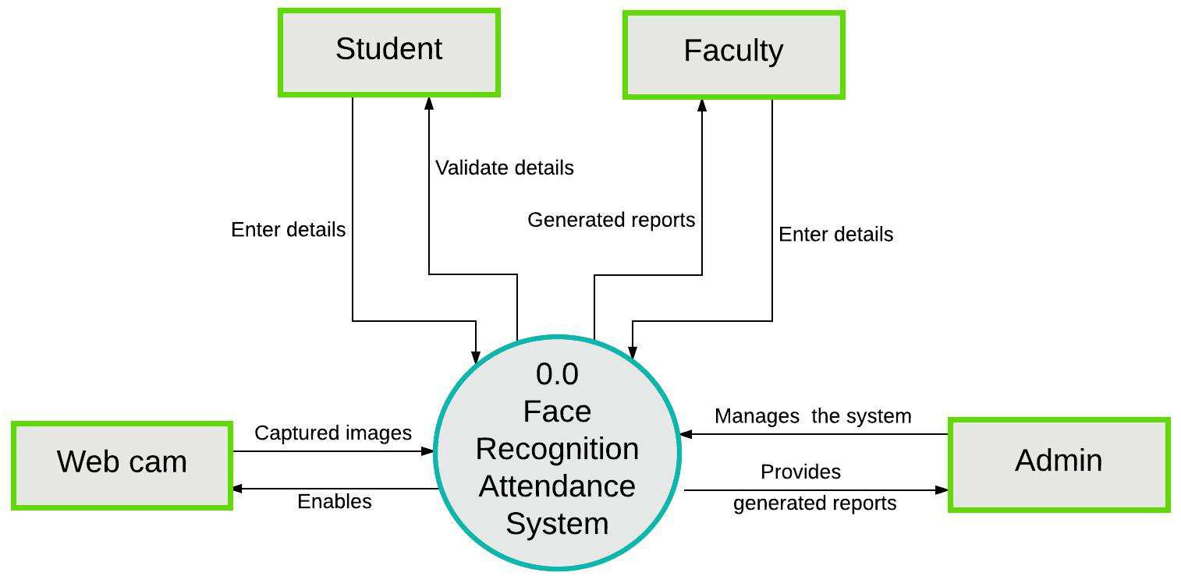

Figure 10 DFD : Context Level
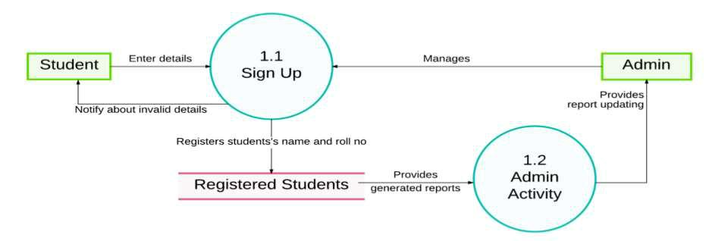

Figure 11 DFD : Context 2Level

Software Requirements Specification Page12

4.2.1 Student Registration Flow
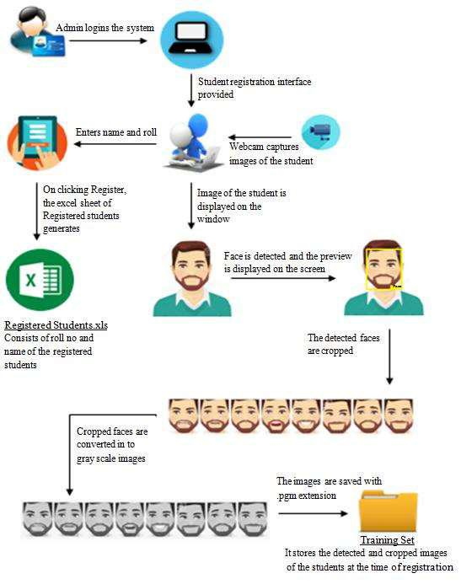

Figure 12 Student Registration Flow

Software Requirements Specification Page13

4.2.2 Attendance Flow
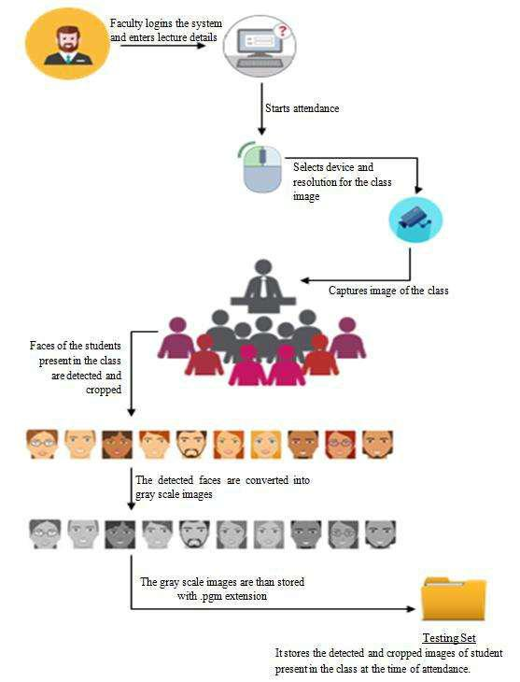

Figure 13 Taking Attendance Flow

Software Requirements Specification Page14

Feature Extraction
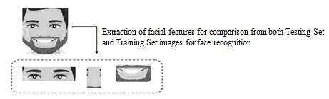

Figure 14 Feature Extraction

4.2.3 Generating Attendance Flow
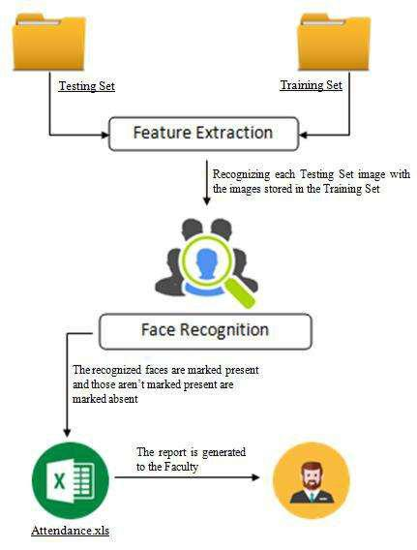

Figure 15 Generating Attendance Flow

Software Requirements Specification Page15

5.0 Non-Functional Requirements

The few non-functional requirements that we have added which leads to the smooth working and better experience while operating on the project are mentioned below.

Accuracy and Precision:

The system should perform its process in accuracy and Precision to avoid problems.

Modifiability:

The system should be easy to modify, any wrong should be correct.

Security:

The system should be secure and saving student’s privacy.

Usability:

The system should be easy to deal with and simple to understand.

Maintainability:

The maintenance group should be able to fix any problem occur suddenly.

Speed and Responsiveness:

Execution of operations should be fast.

Software Requirements Specification Page16

6.0 Logical Database Requirements

Logical classification of data entities as well as their attributes.


Data | Attributes |  | Use
Software Input Data |  | Faculty Username and | This data is used to identify
 |  | password | the faculty and lecture whose
 |  | Lecture details | attendance is going to be
 |  |  | uploaded.

Software Output Data |  | Faculty name
 |  | Lecture detail

Roll no. of student Present

Roll no. of student absent

The result data is used to inform the faculty about student attendance as per the lecture.

Software Required Data |  | Each Student image data set
 |  | Student name with roll no.

This data is stored on the back end server and used to identify the student.

Software Requirements Specification Page17

Software Requirements

Specification

Page1

